**COMP 266 – INTRODUCTION TO WEB PROGRAMMING**

**UNIT 1 – SITE DESIGN**

**SOPHIE CIARDULLO**

**3533153 – SOPHIECI1**

**JUNE 4, 2021**

**I – INTRODUCTION**

**II – PERSONAS**

II.I – Christopher Pearson

II.II – Jeanne Fields

II.III – Tom Ryan

II.IV – Damian Lee

II.V – Naomi Phillips

II.VI – Annie Walker

II.VII – Wilma Lewis

**III – SITE MAP**

III.I – Site Map Legend

III.II – Simplified Site Map

III.III – Detailed Site Map

**IV – PAGE LAYOUTS**

IV.I – Home

IV.II – About

IV.III - Shop

IV.IV – Shop; All Products

IV.V – Shop; Sale & Bundles

IV.VI – Shop; Clothing

IV.VII – Shop; Stickers

IV.VIII – Shop; Stationery

IV.IX – Custom Orders

IV.X – Custom Orders; Clothing

**TABLE OF CONTENTS**

IV.XI – Custom Orders; Stickers

IV.XII – Bulk Orders

IV.XIII – Bulk Orders; Clothing

IV.XIV – Bulk Orders; Stickers

IV.XV – Help Page

IV.XVI – Help Page; Sizing + Care Instructions

IV.XVII – Help Page; FAQ

IV.XVIII – Help Page; Contact

**V – COLOURS**

**VI – LEARNING OUTCOME MAPPING**

**VII - REFERENCES**

**I - INTRODUCTION**

**MOTIVATION & GOALS**

I want to build this website to expand the online presence of my small business. I started SVCrafted on January 1st of 2021 as a custom clothing brand. Since then, I have also extended my product portfolio to include stickers and stationery. All three of these main product types are available in bulk orders, as I feel confident in my experience with bulk orders to make it a widely available option. To this date, majority of my business presence is on Instagram, and my sales are done through Etsy. My main goal in creating this website is to have a central space which encompasses who I am as a business owner as well as my goals, shows my portfolio, and provides an opportunity for people to buy my products.

More detailed goals for my website include the following:

* Introduce myself and my brand.
* Showcase my portfolio and standard products that are available.
* Provide information on bulk orders:
  + Products that can be ordered in bulk.
  + Pricing & Shipping.
  + How to place a bulk order.
* Allow for customers to buy products directly on the website.
* Provide a positive user experience.

**TARGET AUDIENCE & VISITOR MOTIVATION**

The target audience for this website is quite vast, as really anyone could buy my products. SVCrafted ships internationally, so having the website available in different language and being considerate of cultural norms across the world is important. While the website is not by any means limited to a certain age group, I will be catering my goals and design to people between the ages of 16 and 60. Given the analytics of my current sales, a large majority of the people who buy my products are right at the lower or higher ends of this range; specifically, between 16-25 and 40-50.

I expect visitors to have varying reasons for visiting my site. Some people will be visiting my site after hearing about my business from a friend or family member, or perhaps seeing SVCrafted on Instagram or Etsy. Some people will visit with the intention of buying a product, while some will just be visiting with intention of looking at my portfolio and learning more about my business.

**THEMES**

Along with the goal of providing a positive user experience, I intend to use colours, fonts, and images that are bright and colourful to instill positive emotions in the user as they go through the website.

**II.I - CHRISTOPHER PEARSON**

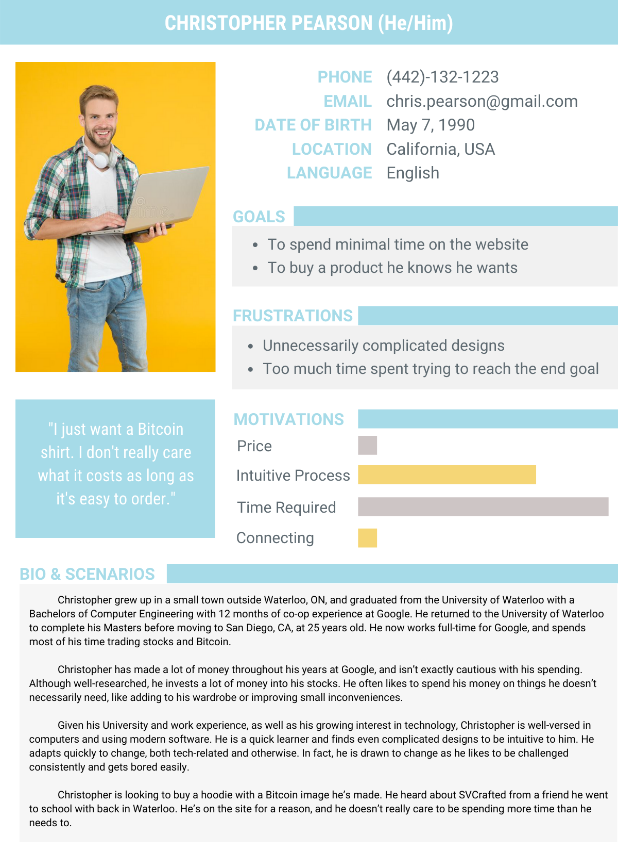

**II.II - JEANNE FIELDS**

**II.III - TOM RYAN**

**II.IV - DAMIAN LEE**

**II.V - NAOMI PHILLIPS**

**II.VI - ANNIE WALKER**

**II.XII - WILMA LEWIS**

**NOTE**

There are two versions of the site map:

* Simplified Site Map: the secondary page connectors are removed to show the direct flow between pages, without the indirect connection via the menu tab.
* Complete Site Map: the secondary page connectors are included to show the direct flow between pages, as well as the indirect connection via the menu tab.

**III.I – SITE MAP LEGEND**

**III.II – SIMPLIFIED SITE MAP**

**NOTE:** All level 2 & 3 pages are accessible via the menu at the top of each page.  
**NOTE:** The home page is accessible via the menu at the top of each page.

**III.III – DETAILED SITE MAP**

**NOTE:** All level 2 & 3 pages are accessible via the menu at the top of each page.  
**NOTE:** The home page is accessible via the menu at the top of each page.

`

Click to be redirected to Home page at any time

Click to be redirected to Custom Orders page

Click to be redirected to All Products page

Click to be redirected to About page

**IV.I – HOME PAGE**

**IV.II – ABOUT**

Click to be redirected to Clothing page

Click to be redirected to Sales & Bundles page

Click to be redirected to Stickers page

**IV.III – SHOP**

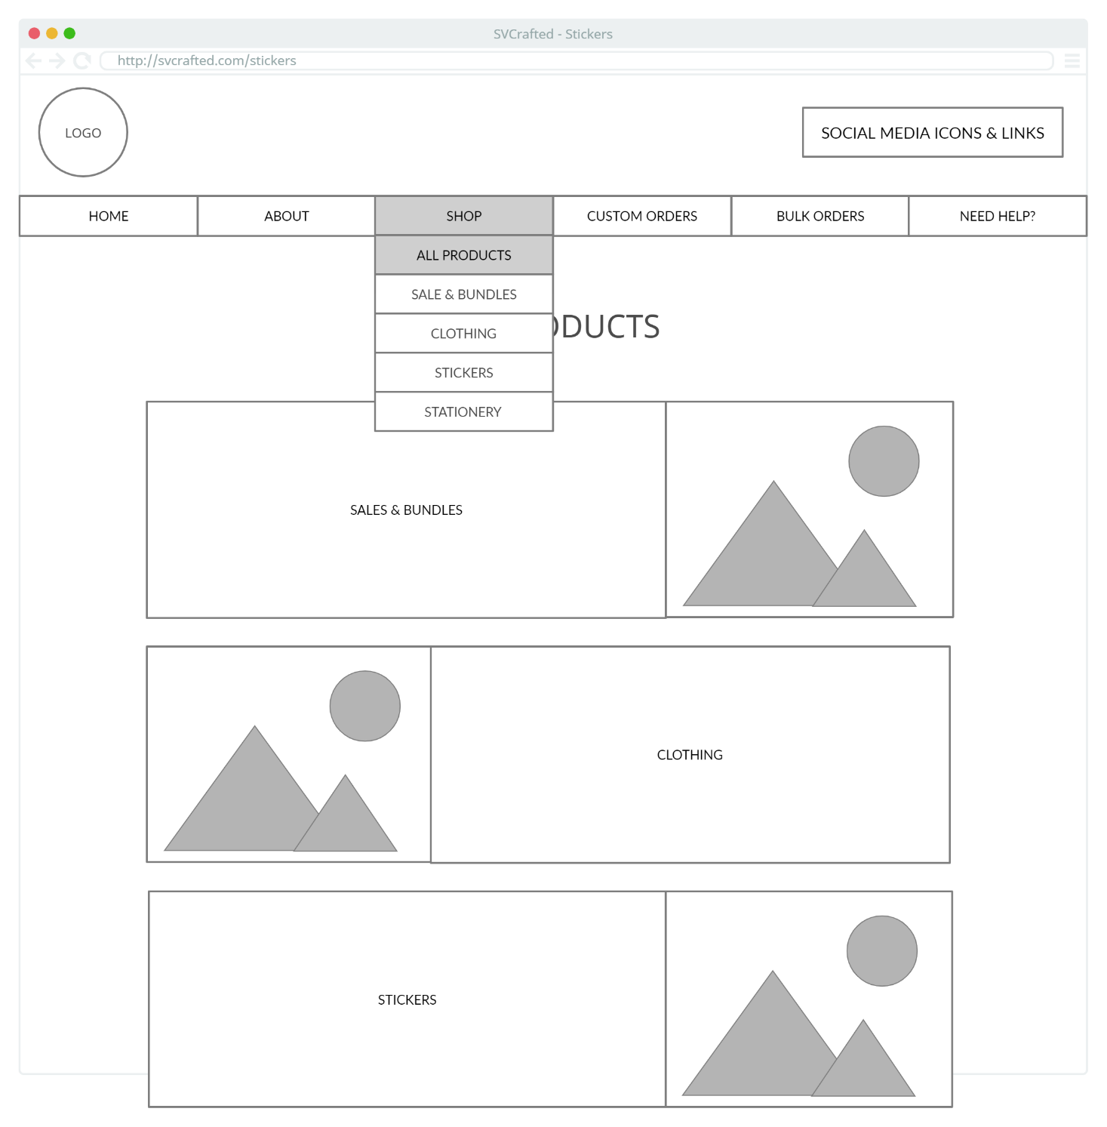

**IV.IV – SHOP; ALL PRODUCTS**

Click any image or product name to be redirected to an individual product page

**IV.V – SHOP; SALES & BUNDLES**

**IV.VI – SHOP; CLOTHING**

Click any image or product name to be redirected to an individual product page

Click any image or product name to be redirected to an individual product page

**IV.VII – SHOP; STICKERS**

Click any image or product name to be redirected to an individual product page

**IV.VIII – SHOP; STATIONERY**

Click to be redirected to custom stickers page

Click to be redirected to custom clothing page

**IV.IX – CUSTOM ORDERS**

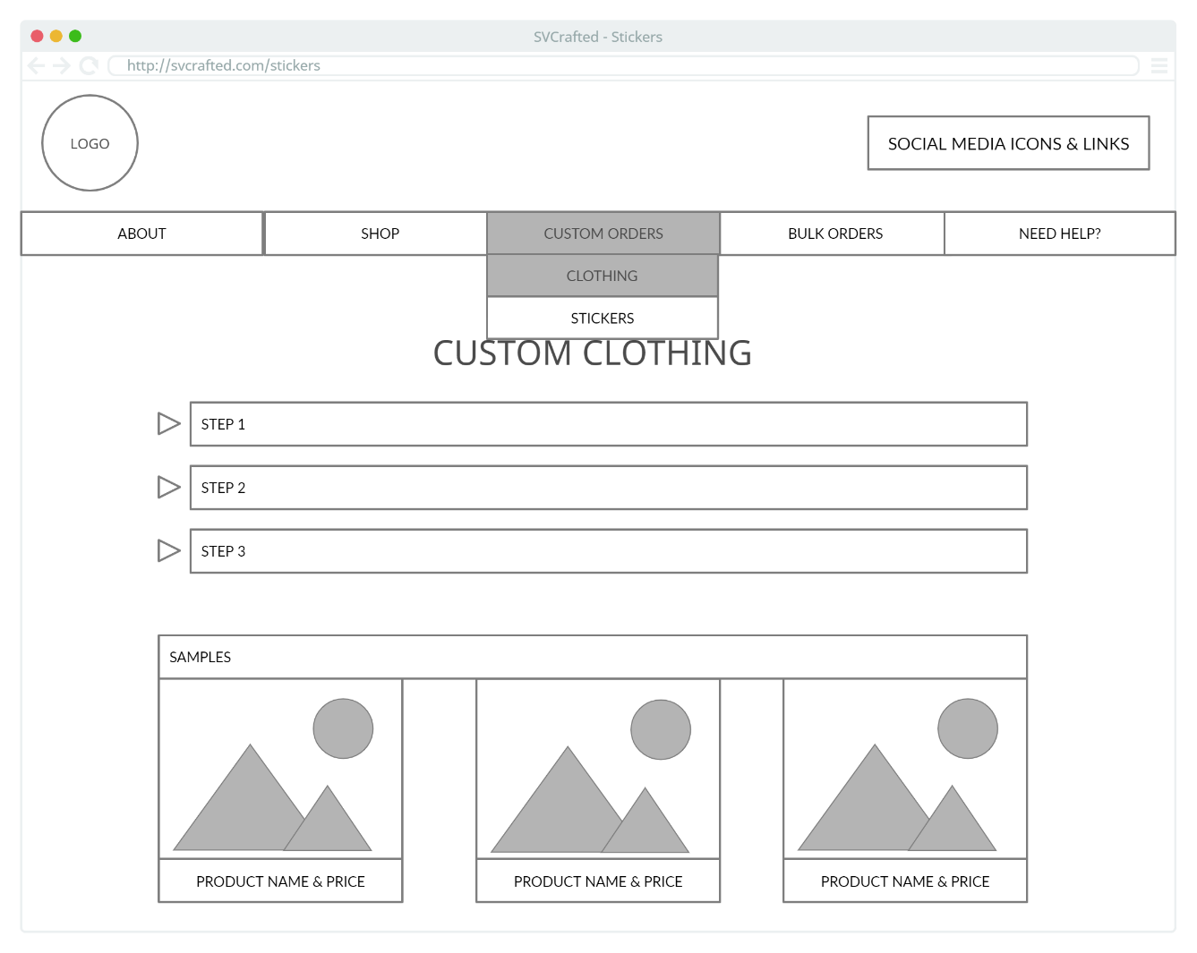

Click expansion arrows for info on each step

**IV.X – CUSTOM ORDERS; CLOTHING (I)**

Click expansion arrow to collapse info for given step

Click expansion arrows for info on each step

**IV.X – CUSTOM ORDERS; CLOTHING (II)**

Click expansion arrows for info on each step

**IV.XI – CUSTOM ORDERS; STICKERS (I)**

Click expansion arrow to collapse info for given step

Click expansion arrows for info on each step

**IV.XI – CUSTOM ORDERS; STICKERS (II)**

Click to be redirected to bulk clothing page

Click to be redirected to bulk stickers page

**IV.XII – BULK ORDERS**

BULK CLOTHING

Click expansion arrows for info on each step

**IV.XIII – BULK ORDERS; CLOTHING (I)**

Click expansion arrows for info on each step

Click expansion arrow to collapse info for given step

**IV.XIII – BULK ORDERS; CLOTHING (II)**

Click expansion arrows for info on each step

**IV.XIV – BULK ORDERS; STICKERS (I)**

Click expansion arrows for info on each step

Click expansion arrow to collapse info for given step

**IV.XIV – BULK ORDERS; STICKERS (II)**

Click to be redirected to contact info page

Click to be redirected to FAQ page

Click to be redirected to sizing + care page

**IV.XV – HELP PAGE**

Click expansion arrows for each product’s sizing

Click expansion arrow to collapse sizing for given product

**IV.XVI – HELP PAGE; SIZING + CARE INSTRUCTIONS**

Click expansion arrows for info on each step

**IV.XVII – HELP PAGE; FAQ (I)**

Click expansion arrows for info on each step

Click expansion arrow to collapse info for given step

**IV.XVII – HELP PAGE; FAQ (II)**

**IV.XVIII – HELP PAGE; CONTACT**

**V – COLOUR PALLETTE**

**[1] Apply a structured approach to identifying needs, interests, and functionality of a website.**

Grade I believe would be appropriate: A

Justification:

* Sections I, III, and IV include a description of the website’s purpose and goals, as well as a site map and page layouts. These three sections clearly identify the needs, interests, and functionality of this website.
* The needs, interests, and functionality of the website are also tailored towards varying personas and scenarios, outlined in Section II.

**[2] Design dynamic websites that meet specified needs and interests.**

Grade I believe would be appropriate: A

Justification:

* Section IV includes page layouts for each page, showing the interactivity with different elements on the page as well as the dynamic elements of each page.

**VI – LEARNING OUTCOME MAPPING**

**IMAGES**

[1] https://randomuser.me/

[2] https://d1bvpoagx8hqbg.cloudfront.net/259/0124c64ee40ad8daa8e8c4d468a1c21f.jpg

[3] https://thumbs.dreamstime.com/b/hipster-cheerful-bearded-face-holding-laptop-laptop-computer-  
repairman-tech-worker-notebook-work-entertainment-guy-154642192.jpg

[4] https://media.istockphoto.com/photos/woman-in-front-of-pine-trees-in-city-market-picture-id1083481574?k=6&m=1083481574&s=612x612&w=0&h=yLPmD8T8FIW4W_pFnpQPnPPiJ7Hp2OPhQYWAT9gWl0o=

[5] https://specials-images.forbesimg.com/imageserve/5ed96ce9b0128d00064fbedc/960x0.jpg?fit=scale

[6] https://media.istockphoto.com/photos/smiling-student-in-the-park-picture-id1064560620?k=6&m=1064560620&s=612x612&w=0&h=cAe8xFwUpEP4gdqb69O87p7W-jE2j_B1OTA807ofb2U=

**PERSONAS + SCENARIOS**

[1] https://sites.google.com/site/superuserfriendly/templates/persona-template

[2].https://www.google.com/search?q=persona+example+web+development&rlz=1C1CHBF_enCA902CA902&sxsrf=ALeKk03j0h20QWxY6j1bfXNuUaQ79lBVtw:1623268349973&source=lnms&tbm=isch&sa=X&ved=2ahUKEwjV1f_qqYvxAhU5KFkFHfbFC6IQ_AUoAXoECAEQAw&biw=767&bih=712#imgrc=j9hktteFeBxF9M

**SITE MAP + PAGE LAYOUTS**

[1].https://creately.com/?gclid=Cj0KCQjwzYGGBhCTARIsAHdMTQyRIeWOjhRzLhZXZHJnOXe9g69RrXZBEIJ2N3JDU7bEhFL0i6mf1yQaAurzEALw_wcB

[2] https://boxesandarrows.com/site-diagrams-mapping-an-information-space/

**VI – REFERENCES**